4/27/2024
Ratia SB StudNo. 230724477
Cape app development pty ltd
T2 Progress Report
Scrum Master report

Table of Contents
Term 1 Project 2: Individual Deliverables 2
MY ROLE IN A GROUP 3
Role 4
Tasks 4
Backend Development: 4
Code Refactoring: 4
Lessons Learned 4
Moving Forward 5
Tasks Completed 7
Tasks not completed. 7
POSSIBLE IMPROVEMENTS 8
Possible Improvements 9
Group 9
Individual 9
LESSON LEARNED 10
Lesson Learned 11
ANNEXTURE A 12
ANNEXTURE B 13
ANNEXTURE C 16
ANNEXTURE D 17

Term 1 Project 2: Individual Deliverables

The following are covered in this document:

- My role in the group.◦

- Allocated tasks in the group, tasks completed and outstanding tasks.

- Suggest possible improvements for the group and for you as an individual.

- Lesson learned.

- LinkedIn Learn certificate of the courses completed to aid the group to develop the application.

Role
I have assigned specific roles and tasks to each team member based on their skills and interests. This includes frontend development, backend coding, testing, database design, and documentation. Regular meetings and communication channels are established to ensure everyone is aware of their responsibilities. Every team member is urged to tell if he or she needs assistance or support. I always avail myself to help support my team.

Tasks
UI Layout Design: I have successfully designed the UI layout for the library system using Vue.js. The design incorporates user-friendly features and a visually appealing interface to enhance the user experience.

Backend Development:

I have started coding the backend using the Spring framework. This involves creating the necessary endpoints, handling API requests, implementing business logic, and integrating with the database. The backend development aims to provide robust and secure functionalities for the library system.

Code Refactoring:

While we are still in the early stages of development, I understand the importance of code quality and maintainability. Once the entire system is developed, we plan to conduct a thorough code review and perform necessary refactoring to improve code structure, efficiency, and readability.

Lessons Learned

Throughout the project, several key lessons have been learned:

Effective Project Management: Completing a project management course was essential in understanding the responsibilities and expectations of a group leader. I have learned valuable strategies for managing the team, setting goals, monitoring progress, and ensuring effective communication among team members.
Technical Challenges: The project has provided opportunities to enhance technical skills, particularly in backend development using the Spring framework and frontend development with Vue.js. Overcoming challenges like CORS has deepened our understanding of web application development.
Collaboration and Teamwork: The project emphasized the significance of effective collaboration and teamwork. Regular meetings, clear communication channels, and distributing tasks based on individual strengths have been instrumental in keeping the project on track.

Moving Forward

As we progress further in the project, our next steps include integrating the frontend and backend components, implementing additional functionalities, conducting thorough testing, and refining the overall system based on user feedback. We remain committed to delivering a robust, user-friendly library system that meets the project's objectives.

If there are any specific areas you would like to expand on or any particular information you would like to include, please let me know, and I'll be happy to assist you further!

Tasks Completed
When started working on this project I served as a founder and leader. As a founder I have Invited members to join the team. I then issue out the task to come up with a problem to be solved using software development skill we have obtained from first year. People responded positively and came up with different ideas. As a leader I then scheduled a meeting to plan the start of the project. I have chaired the meeting as shown in the minutes of the meeting in Annexture A.
I have gone through the agile foundations linkedin course attached certificate in Annexture B which were recommended by the other supervisor. I have learned much more about my role which I later became amazed, I worked as a scrum master. I have continued with self-learn following the course Software Design: Modelling with UML (certificate attached in Annexture B). I have initiated creating the github account and learning how to use it (see the screenshot and link in Annexture C). I also urged my teams to create the accounts and accept our organization github invitation I have issued out. The task was completed successfully.
As a Scrum Master I was also assigned to make sure the group documentation is completed on time and it is in one simple format that can be accessible by the supervisor. The task was completed successfully.

Tasks not completed.
I am still learning more on saving the coding on github and enabling group members to work and save their work on it. I am still going to provide the training and support to the group members on implementing agile mindset up to delivering the best Shoprite online shopping App.
I am still identifying various strengths and weaknesses among members. I am still planning to design scrum board for term 2 deliverables delegate tasks for them to work on and provide guidance and direction of completing the task on time.

POSSIBLE IMPROVEMENTS

Possible Improvements

Group
As a group, we can improve our communication regarding skill learning courses of individuals. We can also improve our collaboration by assigning clear roles and responsibilities to each member, and by setting realistic timelines and deadlines for tasks and keep on checking if people are doing their given task and not need some support and clarifications. It may also be essential to have a feedback system to ensure that everyone's concerns and ideas are heard and addressed.

Individual
As an individual, I can improve my time management skills and prioritize my tasks more effectively using my git project management. I can also work on improving my technical skills by studying courses in linkedin that are going to be helpful to development of the app, and by staying up to date with the latest technologies and trends in the field. Additionally, I can work on improving my communication and teamwork skills by actively seeking out feedback from my team using Microsoft office review form and learning to effectively communicate my ideas and concerns to my team.

LESSON LEARNED

Lesson Learned
As the project manager and technical lead of the team, I have learned a lot of valuable technical and soft skills. From a technical point of view, I have gained a deeper understanding of software development. I have learned software development is not only about programming but more on project management, I also learned the importance of database design. I am also enhancing my skills in using various programming languages, frameworks, and tools such as Java, Git, and Agile methodologies.

On the soft skills side, I have developed my leadership, communication, and collaboration skills. As the team leader, I have learned how to effectively manage and guide a team, delegate tasks, and coordinate efforts towards a common goal. Communication plays a vital role in this role, and I have learned how to communicate effectively with team members, stakeholders. Collaboration is essential. I have learned how to work with others, build trust, and create a positive team culture.

Most importantly, I have learned the importance of time management, prioritization, reduce of multitasking, and problem-solving. Being able to manage my time effectively, prioritize tasks, and solve problems quickly and efficiently has been crucial in ensuring that the project stays on track and meets its deadlines.

Serving as the scrum master and technical lead is challenging and rewarding experience. It has enabled me to develop and strengthen my technical and soft skills, and I am proud to continue learning and growing in this role. I am also willing to register Cape App Development Pty Ltd and create job opportunities, that way I will be contributing to South African economy.

ANNEXTURE A
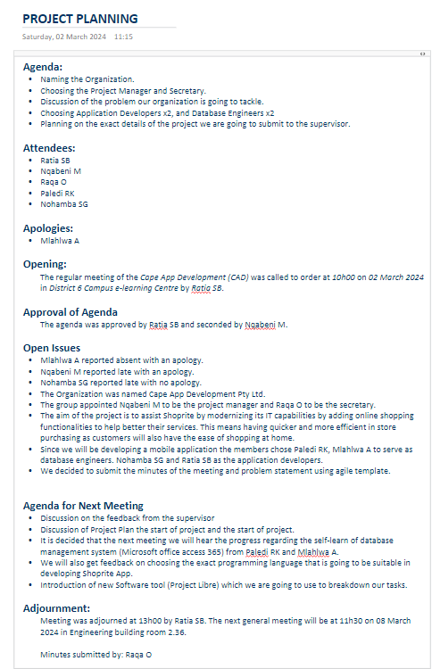

ANNEXTURE B

- - CertificateOfCompletion_Agile Foundations National Association of State Boards of Accountancy (NASBA)
- - CertificateOfCompletion_Agile Foundations Project Management Institute (PMI)®

- - CertificateOfCompletion_Agile Foundations International Institute of Business Analysis™ (IIBA®)

- - CertificateOfCompletion_Agile Foundations

- - CertificateOfCompletion_Software Design Modeling with UML

ANNEXTURE C

Cape App Development Account

Link: https://github.com/CAPE-APP-DEVELOPMENT/ShopRite-Mobile-App.git

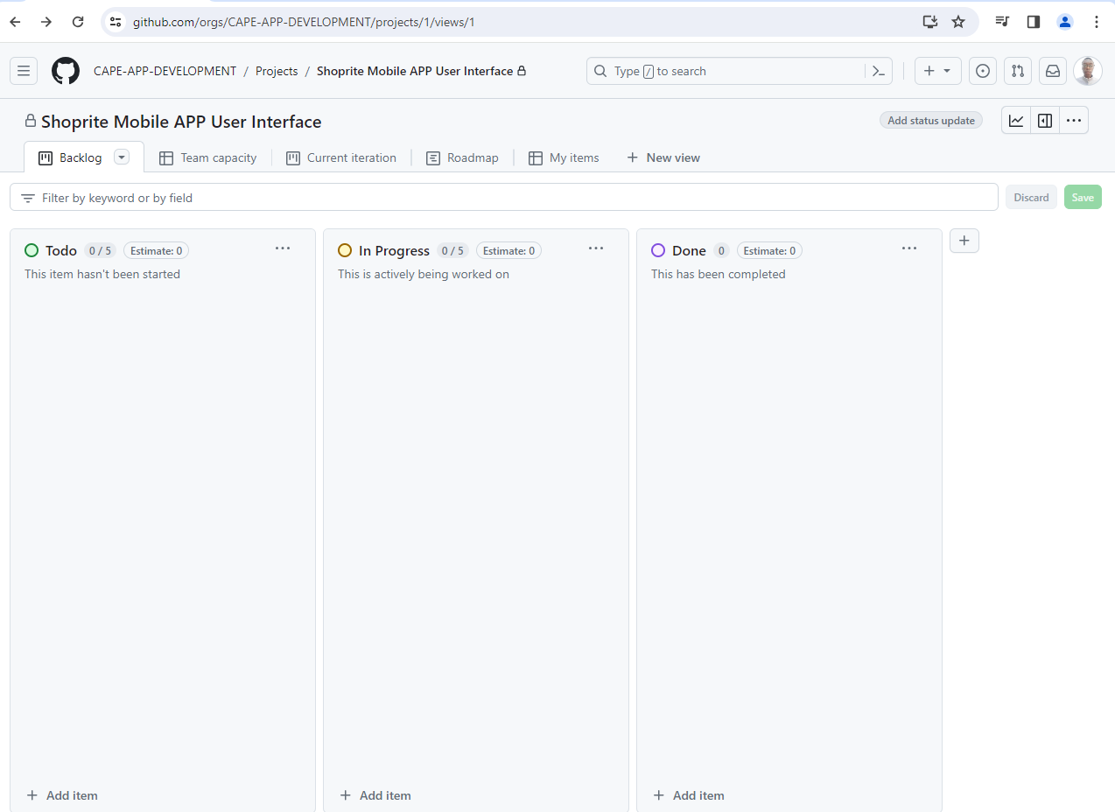

ANNEXTURE D

Scrum Master Github Account

Link: https://github.com/RatiaSB

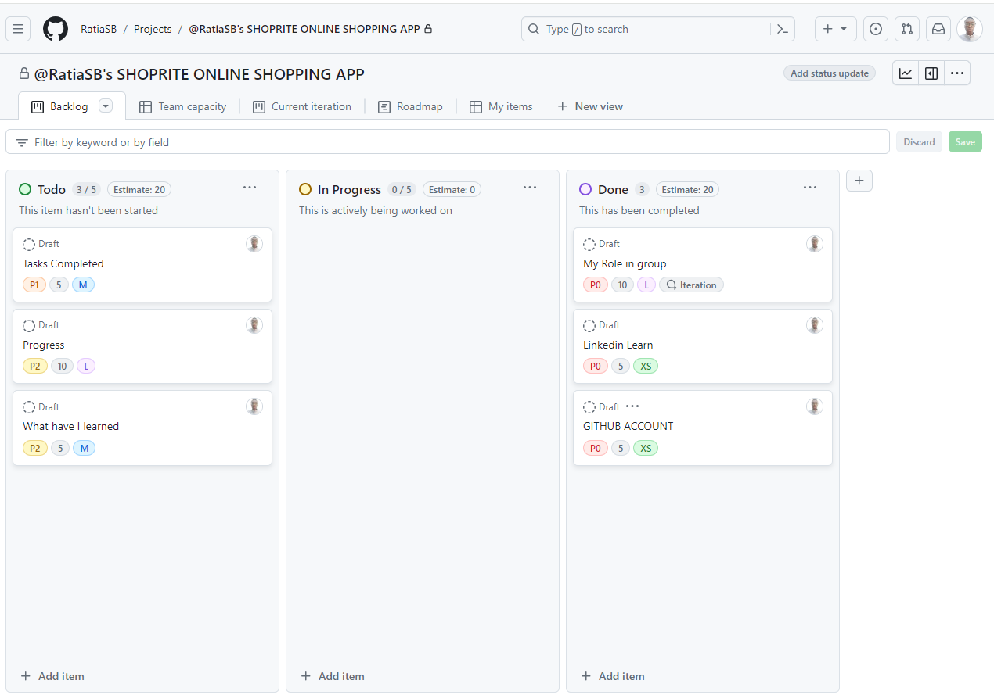

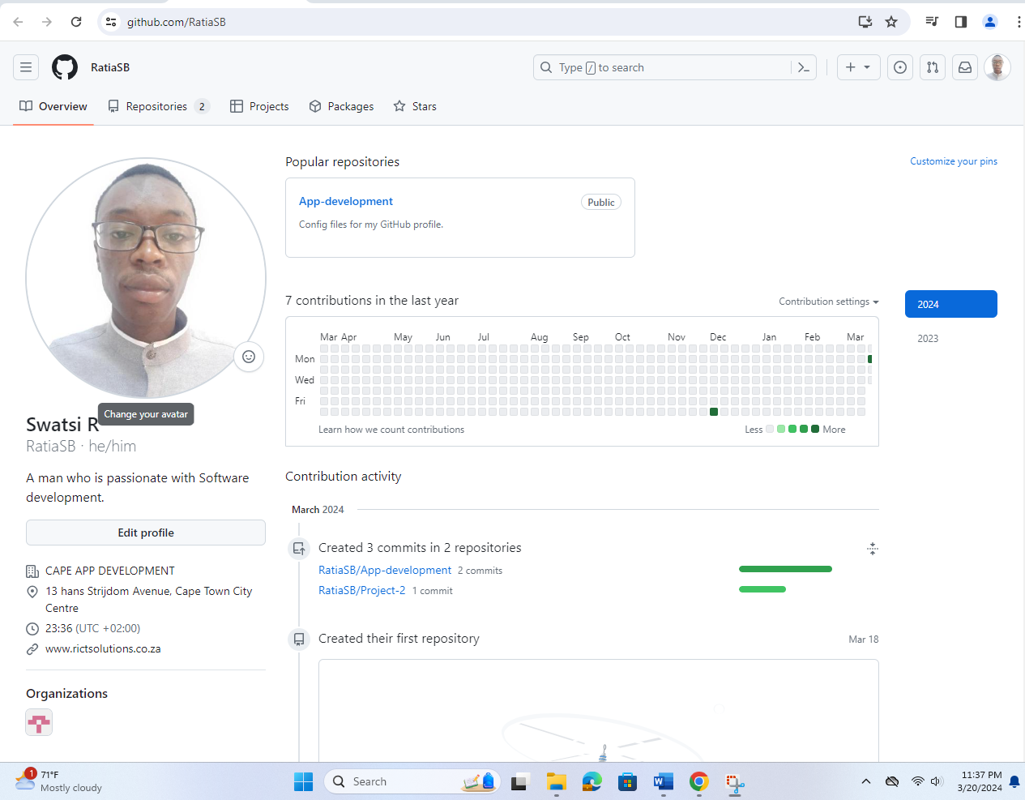

ANNEXTURE E
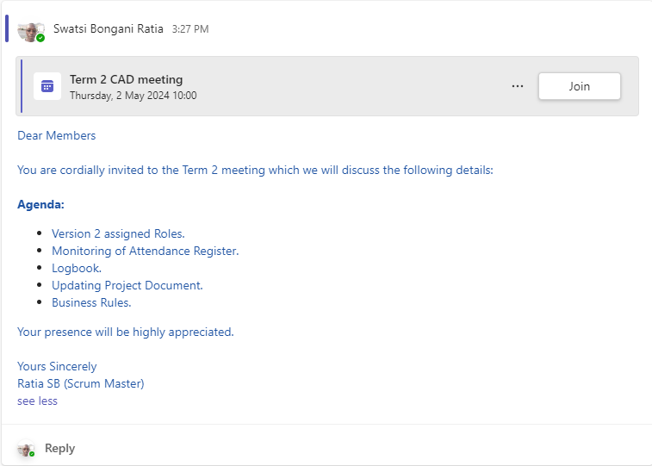
Figure 1Term 2 Meeting invite created using MS Teams

